Posted by Rodrigo Assis at 3:23 PM 0 comments

Tuesday, March 10, 2009

Installing and configuring Sun Cluster 3.2 x86 on VMware Server

This tutorial will explain step-by-step how to setup Sun Cluster 3.2 (two-node cluster) using VMware Server (free).

This environment is very useful for lab purposes and also as a tool to study for SC 3.2 certification.

First of all, you need to download and install VMware Server (I'm currently using version 1.0.8). After installing VMware, we'll need to setup two Solaris 10 VM servers (use the custom option on the virtual machine configuration).

Now, this is a very important part to pay attention (#1):

1 - You will need to check if your CPU has the Intel Virtualization Technology (Intel® VT) or Pacifica (AMD) :

http://en.wikipedia.org/wiki/X86_virtualization

2 - If your CPU doesn't have support for 64-bit virtual machines (in my case), VMware will show a message stating that 64-bit OSs won't be supported:

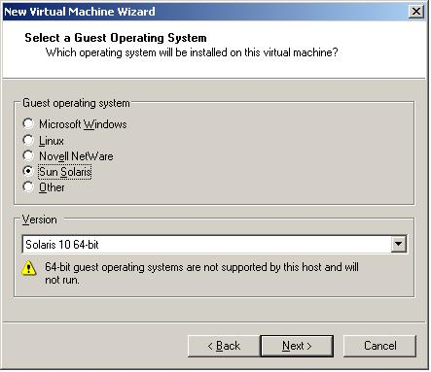

3 - If this message doesn't appear, then you probably have a CPU that supports 64-bit virtualization (so you can proceed with Solaris 10 - 64-bits).

4 - If you don't have support for 64 bits VM, you will have to use "Solaris 10" version (I will give further instructions regarding how to download/install 32-bit modules for Sun Cluster - without this module you won't be able to use SC 3.2 under 32-bit VMs).

5 - Memory for VM - I strongly recommend setting at least 1GB for each VM, if you plan to use Oracle DBs under the cluster management (otherwise 512-768 MB should suffice).

6 - Network connection - Leave the default option (Use bridged networking - later on we'll setup two additional network adapters that will be used as the transports for the cluster).

7 - SCSI Adapter - Choose "LSI Logic"

8 - Disk - Choose "Create a new virtual disk", SCSI as virtual disk type and 15 GB of disk space

9 - Now, we need to setup two additional network adapters for the cluster transporter (for that, click on Edit virtual machine settings and then click on Add button.

10 - Choose Ethernet Adapter as the hardware type.

11 - Choose Custom and VMnet1 (Repeat the steps 9-10-11, but now you will have to choose VMnet2)

12 - Go to Host >> Virtual network settings in the menu.

13 - Click on Host virtual adapters tab and add a new VMnet -> (VMnet2)

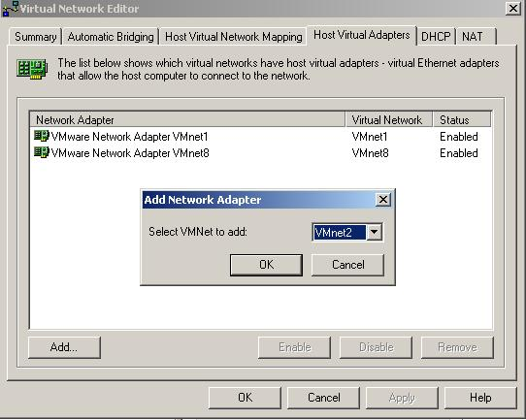

14 - Now we need to add another disk that will be the quorum disk (click on Edit Virtual Machines and then click on the ADD button)

15 - Add the disk as a SCSI disk, name it as quorum.vmdk and use around 100MB of disk space.

16 - Create a similar VM (another hostname) with the same HW settings (after that, add the quorum.vmdk using the same SCSI ID using the option "Use an existing virtual disk")
17 - Now, another important part - you will need to edit your VM config file to allow SCSI reservations (for that you need to disable disk locking and add the following lines into your VM config file - Hint: VM config file ends with a .VMX extension):

disk.locking = "false"
scsi0.sharedBus = "virtual"

-- These lines must be added on both VMs config file --

Now we are all set to start installing Solaris 10 and configure Sun Cluster. Boot your VM from the CD-ROM using a recent Solaris 10 ISO image (I'm assuming you have enough knowledge to make a fresh Solaris 10 install, so I will only specify the filesystem sizes to be set during the install):

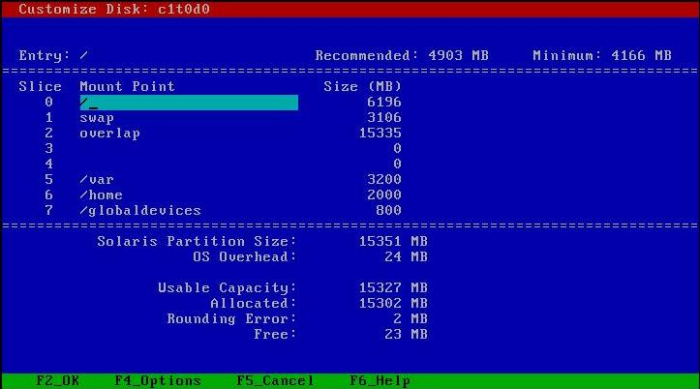

Wait for the installation/reboot to finish and we should have 2 VMs running Solaris 10 (32 or 64 bits). Now we need to install VMware tools to convert the PCN devices to VMXNET devices (I had some problems while trying to install SC 3.2 using PCN, so I strongly recommend to install it).

To install VMware tools, click with the right button on your VM name and choose "Install VMware tools" (have in mind that you need to unmount any cd-rom currently mounted - after clicking it, VMware will mount a virtual cdrom on the server(s) containing the drivers you will have to install):
/vol/dev/dsk/c0t0d0/vmwaretools 1568 1568 0 100% /cdrom/vmwaretools
Go to /cdrom/vmwaretools (or whatever the mount point is), copy the file to /var/tmp/vmtools, uncompress it and run the installation perl script:

# cd /cdrom/vmwaretools
# ls -la

total 2973
dr-xr-xr-x 2 root sys 2048 out 30 22:39 .
drwxr-xr-x 3 root nobody 512 mar 12 23:38 ..
-r--r--r-- 1 root root 1519013 out 30 22:39 vmware-solaris-tools.tar.gz

# mkdir /var/tmp/vmtools
# cp vmware-solaris-tools.tar.gz /var/tmp/vmtools
# cd /var/tmp/vmtools
# gzcat vmware-solaris-tools.tar.gz | tar xvf -
# cd vmware-tools-distrib
# ./vmware-install.pl

Hit ENTER for all options (default) and when you finish don't forget to do the following:

* Rename your hostname.* files on /etc:

# ls -l /etc/hostname*
-rw-r--r-- 1 root root 6 mar 12 16:48 /etc/hostname.pcn0
# mv /etc/hostname.pcn0 /etc/hostname.vmxnet0

* Replace entries on /etc/path_to_inst (from PCN to VMXNET):

# cp /etc/path_to_inst /etc/path_to_inst.backup ; sed -e 's/pcn/vmxnet/g' /etc/path_to_inst >> /etc/path_to_inst.2 ; mv /etc/path_to_inst.2 /etc/path_to_inst

* Reboot the server (init 6)

After reboot process you should have the vmxnet module properly loaded and your vmxnet0 interface up (check with ifconfig -a).

*Optional* - I strongly recommend to follow this step, but you can configure SC without remote access control if you want:

To make things easier during the install, create a new ssh key as root (hit ENTER for everything) and copy the public file for the secondary node (/.ssh).

# ssh-keygen -t dsa
Generating public/private dsa key pair.
Enter file in which to save the key (//.ssh/id_dsa):
Created directory '//.ssh'.
Enter passphrase (empty for no passphrase):
Enter same passphrase again:
Your identification has been saved in //.ssh/id_dsa.
Your public key has been saved in //.ssh/id_dsa.pub.
The key fingerprint is:34:8e:32:54:b4:bb:d2:5e:71:ec:55:01:09:cd:34:a3 root@earth

Connect on the secondary node and rename the public file to authorized_keys

Try to connect by SSH/SFTP and see if you will be asked for a password (if you did everything right, you won't be asked for a password).

We are ready to start installing/configuring Sun Cluster. Download Sun Cluster 3.2 x86, upload it on both VMs, unzip and run installer (on Solaris_x86 subdir).

* Choose option 4,5,6 to install (everything else is default - hit ENTER)

Enter a comma separated list of products to install, or press R to refresh the list [] {"<" goes back, "!" exits}: 4,5,6

Choose Software Components - Confirm Choices
--------------------------------------------
Based on product dependencies for your selections, the installer will install:
[X] 4. Sun Cluster 3.2
* * Java DB 10.2
[X] 6. Sun Cluster Agents 3.2

Important Step:

If your CPU doesn't have support for IVT or Pacifica (as I explained before), you will have to install the 32-bit modules for Sun Cluster 3.2 (unfortunately I'm not authorized by the author to distribute the package, but your can obtain it by sending an email for Matthias Pfuetzner from Sun Microsystems - as I did to obtain it).
* State in the email that you wan to use it only for *LAB* purposes (he told me that Sun doesn't give support for 32-bit clusters, thus you will only be able to obtain this module by sending him an email)
When you download the 32-bit module, install it after unpacking by running pkgadd -d SUNWscka (if you do not install it and your VMs are 32-bit, the cluster WILL NOT work and the modules WILL NOT be loaded during the boot - so, remember to install it if your VMs are 32-bit).

Add the /usr/cluster/bin directory to your PATH variable on /etc/profile (so that you don't have to type the absolute path everytime you need to run a command).

At last! We will configure a cluster now... Before running scinstall, make sure you have both nodes added on each /etc/hosts file!

Run the command scinstall and follow the steps to install a two-node cluster:

# scinstall

*** Main Menu ***

Please select from one of the following (*) options:

* 1) Create a new cluster or add a cluster node
2) Configure a cluster to be JumpStarted from this install server
3) Manage a dual-partition upgrade
4) Upgrade this cluster node
5) Print release information for this cluster node

* ?) Help with menu options
* q) Quit

Option: 1

*** New Cluster and Cluster Node Menu ***

Please select from any one of the following options:

1) Create a new cluster
2) Create just the first node of a new cluster on this machine
3) Add this machine as a node in an existing cluster

?) Help with menu options
q) Return to the Main Menu

Option: 1

*** Create a New Cluster ***

This option creates and configures a new cluster.

You must use the Java Enterprise System (JES) installer to install
the Sun Cluster framework software on each machine in the new cluster
before you select this option.

If the "remote configuration" option is unselected from the JES
installer when you install the Sun Cluster framework on any of the
new nodes, then you must configure either the remote shell (see
rsh(1)) or the secure shell (see ssh(1)) before you select this
option. If rsh or ssh is used, you must enable root access to all of
the new member nodes from this node.

Press Control-d at any time to return to the Main Menu.

Do you want to continue (yes/no) [yes]?

>>> Typical or Custom Mode <<<

This tool supports two modes of operation, Typical mode and Custom.
For most clusters, you can use Typical mode. However, you might need
to select the Custom mode option if not all of the Typical defaults
can be applied to your cluster.

For more information about the differences between Typical and Custom
modes, select the Help option from the menu.

Please select from one of the following options:

1) Typical
2) Custom

?) Help
q) Return to the Main Menu

Option [1]:

>>> Cluster Name <<<

Each cluster has a name assigned to it. The name can be made up of
any characters other than whitespace. Each cluster name should be
unique within the namespace of your enterprise.

What is the name of the cluster you want to establish? cluster-lab

>>> Cluster Nodes <<<

This Sun Cluster release supports a total of up to 16 nodes.

Please list the names of the other nodes planned for the initial
cluster configuration. List one node name per line. When finished,
type Control-D:

Node name (Control-D to finish): earth
Node name (Control-D to finish): mars
Node name (Control-D to finish): ^D

This is the complete list of nodes:

earth
mars

Is it correct (yes/no) [yes]?

Attempting to contact "mars" ... done

Searching for a remote configuration method ... done

The Sun Cluster framework is able to complete the configuration
process with secure shell access (sshd).

Press Enter to continue:

>>> Cluster Transport Adapters and Cables <<<

You must identify the two cluster transport adapters which attach
this node to the private cluster interconnect.

For node "earth",
What is the name of the first cluster transport adapter? vmxnet1

Will this be a dedicated cluster transport adapter (yes/no) [yes]?

All transport adapters support the "dlpi" transport type. Ethernet
and Infiniband adapters are supported only with the "dlpi" transport;
however, other adapter types may support other types of transport.

For node "earth",
Is "vmxnet1" an Ethernet adapter (yes/no) [no]? yes

Is "vmxnet1" an Infiniband adapter (yes/no) [no]?

For node "earth",
What is the name of the second cluster transport adapter? vmxnet2

Will this be a dedicated cluster transport adapter (yes/no) [yes]?

For node "earth",
Name of the switch to which "vmxnet2" is connected [switch2]?

For node "earth",
Use the default port name for the "vmxnet2" connection (yes/no) [yes]?

For node "mars",
What is the name of the first cluster transport adapter? vmxnet1

Will this be a dedicated cluster transport adapter (yes/no) [yes]?

For node "mars",
Name of the switch to which "vmxnet1" is connected [switch1]?

For node "mars",
Use the default port name for the "vmxnet1" connection (yes/no) [yes]?

For node "mars",
What is the name of the second cluster transport adapter? vmxnet2

Will this be a dedicated cluster transport adapter (yes/no) [yes]?

For node "mars",
Name of the switch to which "vmxnet2" is connected [switch2]?

For node "mars",
Use the default port name for the "vmxnet2" connection (yes/no) [yes]?

>>> Quorum Configuration <<<

Every two-node cluster requires at least one quorum device. By
default, scinstall will select and configure a shared SCSI quorum
disk device for you.

This screen allows you to disable the automatic selection and
configuration of a quorum device.

The only time that you must disable this feature is when ANY of the
shared storage in your cluster is not qualified for use as a Sun
Cluster quorum device. If your storage was purchased with your
cluster, it is qualified. Otherwise, check with your storage vendor
to determine whether your storage device is supported as Sun Cluster
quorum device.

If you disable automatic quorum device selection now, or if you
intend to use a quorum device that is not a shared SCSI disk, you
must instead use scsetup(1M) to manually configure quorum once both
nodes have joined the cluster for the first time.

Do you want to disable automatic quorum device selection (yes/no) [no]?

Is it okay to create the new cluster (yes/no) [yes]?

During the cluster creation process, sccheck is run on each of the
new cluster nodes. If sccheck detects problems, you can either
interrupt the process or check the log files after the cluster has
been established.

Interrupt cluster creation for sccheck errors (yes/no) [no]?

Cluster Creation

Log file - /var/cluster/logs/install/scinstall.log.1312

Testing for "/globaldevices" on "earth" ... done
Testing for "/globaldevices" on "mars" ... done

Started sccheck on "earth".
Started sccheck on "mars".

sccheck completed with no errors or warnings for "earth".
sccheck completed with no errors or warnings for "mars".

Configuring "mars" ... done
Rebooting "mars" ... done

Configuring "earth" ... done
Rebooting "earth" ... done

Ok, now you should have both machines working as a cluster (let's check with scstat command):

# scstat
------------------------------------------------------------------

-- Cluster Nodes --
Node name Status
--------- ------
Cluster node: mars Online
Cluster node: earth Online

------------------------------------------------------------------

-- Cluster Transport Paths --

Endpoint Endpoint Status
-------- -------- ------
Transport path: mars:vmxnet2 earth:vmxnet2 Path online
Transport path: mars:vmxnet1 earth:vmxnet1 Path online

------------------------------------------------------------------

-- Quorum Summary --

Quorum votes possible: 3
Quorum votes needed: 2
Quorum votes present: 3
-- Quorum Votes by Node --

Node Name Present Possible Status
--------- ------- -------- ------
Node votes: mars 1 1 Online
Node votes: earth 1 1 Online

-- Quorum Votes by Device --

Device Name Present Possible Status
----------- ------- -------- ------
Device votes: /dev/did/rdsk/d3s2 1 1 Online

------------------------------------------------------------------

-- Device Group Servers --

Device Group Primary Secondary
------------ ------- ---------

-- Device Group Status --

Device Group Status
------------ ------

-- Multi-owner Device Groups --

Device Group Online Status
------------ -------------

------------------------------------------------------------------
------------------------------------------------------------------

-- IPMP Groups --

Node Name Group Status Adapter Status
--------- ----- ------ ------- ------
IPMP Group: mars sc_ipmp0 Online vmxnet0 Online
IPMP Group: earth sc_ipmp0 Online vmxnet0 Online

------------------------------------------------------------------

Your cluster is ready! =)

Below you can find some "must use" tips taken from Geoff Ongley's homepage and also an example taken from ES-345 course material (a simple daemon managed by the cluster - useful to make failover/failback simulations):

Discovered Problems

Interconnect (”Cluster Transport”) is marked faulted

For example, if you do an scstat, or an scstat -W you see:
Transport path: mail-store1:e1000g2 mail-store0:e1000g2 faulted
Transport path: mail-store1:e1000g1 mail-store0:e1000g1 Path online

(at boot it might be “waiting” for quite some time)
In some cases you can disconnect and reconnect the adapter in VMware. However, in others you may have to be more drastic.
Check you can ping the other node via this path - if you can, then you should be all good to run the following commands:
scconf -c -m endpoint=mail-store0:e1000g2,state=disabled

where mail-store0 is your current node, and e1000g2 is the failed adapter. After you’ve done this, you can re-enable it:
scconf -c -m endpoint=mail-store0:e1000g2,state=enabled

And you should now have an online path shortly afterwards:
bash-3.00# scstat -W

-- Cluster Transport Paths --

Endpoint Endpoint Status
-------- -------- ------
Transport path: mail-store1:e1000g2 mail-store0:e1000g2 Path online
Transport path: mail-store1:e1000g1 mail-store0:e1000g1 Path online

All good

Cluster Panics with pm_tick delay [number] exceeds [another number]
Try the following:
- Stop VMs being paged to disk in VMWare (only use physical memory for your VMs). This is a VMWare server, host setting from memory
- Ensure Memory Trimming is disabled for your VMware Server Sun Cluster Guests
- On each Cluster node, in order, configure the heartbeats to be father apart, and have a longer timeout:
scconf -w heartbeat_timeout=60000

scconf -w heartbeat_quantum=10000

Hopefully this will leave you with a much more stable cluster on VMware.

Making a Customized Application Fail Over With a Generic Data Service Resource

In this task, you can see how easy it is to get any daemon to fail over in the cluster, by using the Generic Data Service (so that you do not have to invent your own resource type).

Perform the following steps on the nodes indicated:

1. On all nodes (or do it on one node and copy the file to other nodes in the same location), create a daemon that represents your customized application:

# vi /var/tmp/myappdaemon
#!/bin/ksh
while :
do
sleep 10
done

2. Make sure the file is executable on all nodes.

3. From any one node, create a new failover resource group for your application:

# clrg create -n node1,node2,[node3] myapp-rg

4. From one node, register the Generic Data Service resource type:

# clrt register SUNW.gds

5. From one node, create the new resource and enable the group:

# clrs create -g myapp-rg -t SUNW.gds \
-p Start_Command=/var/tmp/myappdaemon \
-p Probe_Command=/bin/true -p Network_aware=false \
myapp-res

# clrg online -M myapp-rg

6. Verify the behavior of your customized application.

a. Verify that you can manually switch the group from node to node.

b. Kill the daemon. Wait a little while and note that it restarts on the same node. Wait until clrs status shows that the resource is fully online again.

c. Repeat step b a few times. Eventually, the group switches over to the other node.

